# 

# **Software Requirements Specification**

**Topic: Airline Reservation System**

**Submitted By:**

**Anukriti Sharma (20112006)**

**Fathimathul Susna ShoukkathAli (20112013 )**

**Index**

1. **Introduction**

**1.1 Purpose**

**1.2 Document Conventions**

**1.3 Intended Audience and Reading Suggestions**

**1.4 Project Scope**

**1.5 References**

1. **Overall Description**

**2.1 Product Perspective**

**2.2 Product Features**

**2.3 User Classes and Characteristics**

**2.4 Operating System**

**2.5 Design and Implementation Constraints**

**2.6 Assumptions and Dependencies**

1. **System Features**

**3.1 Specification and Priority**

**3.2 Response and Sequence**

1. **External Interface Requirements**

**4.1 User Interfaces**

**4.2 Hardware Interfaces**

**4.3 Software Interfaces**

**4.4 Communication Interfaces**

1. **Non-Functional Requirements**

**5.1 Performance Requirements**

**5.2 Safety Requirements**

**5.3 Security Requirements**

**5.4 Software Quality Requirements**

1. **Diagram**

## **Introduction**

**1.1 Purpose**

The aim of this document is to provide an online system for managing flights and

passengers in order to make flight management more efficient and effective for customers. The Airlines Reservation System's most important task is to maintain the data of airline tickets, flights, and assurance regarding the early facility and availability of the tickets to the customers. It keeps records of all data concerning airline tickets, bookings, providers, and the rescheduled flights which gets notified to the customers immediately. Further we will describe the requirements which will be used in our Airline Reservation system.

**1.2** **Document Conventions**

This following conventions are used in this document:-

(i) Database (DB)

(ii) Distributed Database (DDB)

(iii) Entity Relationship

**1.3** **Intended Audience and Reading Suggestions**

This project is a model for a flight management system that is only available on university grounds. This has been put in place with the help of college instructors. This project is beneficial to both the flight management staff and the passengers to keep records.

**1.4 Project Scope**

The name of the software is “AIRLINE RESERVATION SYSTEM”. The airline booking website is a user-server-based application. This software allows customers to view different flights available with different timings for a specific date and to book, modify, or cancel a specific reservation. The website's aim is to solve the client and allow web application people to complete activities associated with airline flight bookings. Non-member users can only look for available flights but in order to reserve a seat or book a flight, non-member users must create an account. Members can explore for available flights, reserve a seat, book a flight, cancel a flight, and update their personal information. Prior to booking a flight, members must first login to their account.

**1.5 References**

* Bandakkanavar, Ravi. “Software Requirements Specification document with example - Krazytech.” *Krazytech -*, 4 July 2018, https://krazytech.com/projects/sample-software-requirements-specificationsrs-report-airline-database. Accessed 29 May 2022.
* “Flight Booking Process: Airline Reservation, Ticketing, and more.” *AltexSoft*, 20 August 2021, https://www.altexsoft.com/blog/engineering/flight-booking-process-structure-steps-and-key-systems/. Accessed 29 May 2022.
* “Flight Booking Software System | Airline Reservation System.” *Technoheaven*, https://www.technoheaven.net/flight-module.aspx. Accessed 29 May 2022.
* “Top 14 Airline Reservation System in 2022 - Reviews, Features, Pricing, Comparison - PAT RESEARCH: B2B Reviews, Buying Guides & Best Practices.” *PAT Research*, https://www.predictiveanalyticstoday.com/top-airline-reservation-system/. Accessed 29 May 2022.

## **2. Overall Description**

## **2.1 Product Perspective**

## Ease My Trip is an online reservation system which is a news venture which provides the airline to sell their seats. It contains information on schedules and prices which is stored in a database of reservations. Customers have the access to book the flights from anywhere around the world using our Airline Software.

## This system will be storing the following information:

## User Details: This section allows the user to login to their account using username and password. If the user is not registered with the website, they are provided to sign up first using their credentials which consists of name, phone number, aadhaar, email.

## Flight Details: The flight details consist of the available flights according to the needs of the user. This provides the details of flight number, flight name, flight time, flight duration and price of the flight.

## Booking Details: This function assists the user to obtain the seats for the reservation of the flight. The system provides the information of the flights from which the user can select their flight (arrival and departure). The user chooses their seats and category which provides various options of flights.

## Rescheduled Flight: This function shall provide the user to check the rescheduled flight details. Displays Flight Number, Flight Date, Destination, Scheduled Departure, assigned plane Type, Capacity, Seats Reserved and Seats Available.

## 

## **2.2 Product Features:**

## The following are the main features of an airline database system.

ER Diagram

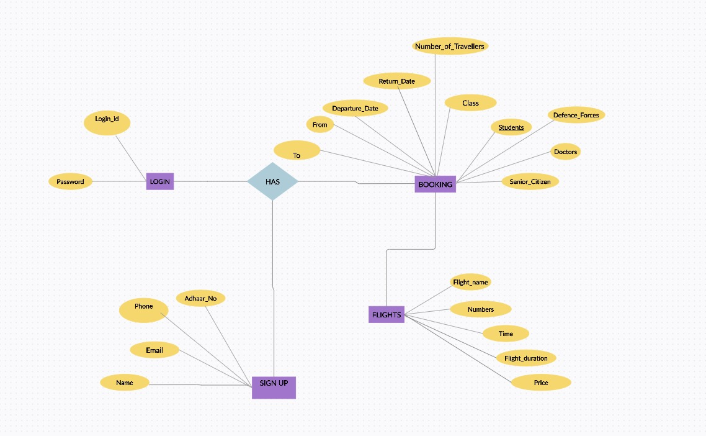

## **2.3 User Classes and Characteristics:**

## The main parts of this system are user, booking, flight details. The user will choose a flight and reserve seats on it. They will then book specific seats on that particular aircraft. The system assists the user to get the necessary information date, time and the necessary information regarding the aircraft. Allows the customer to efficiently use their options and the Employers will have the authority to both booking and flight details.

## - User

## o Has the features like Username and Password.

## - Booking

## o Has features like Departure, Arrival, Number of Travelers, Class, Category of Customer.

## - Flight Details

## o Has the features like Flight Number, Flight Name, Flight time, Flight Duration and Price.

## 

## 

## **2.4 Operating Environment:**

## The developed system is envisioned as a website that could be accessible through any web browser from anywhere around the world. It would not be reliant on the system of the user’s or the competence of the software.

## 

## **2.5 Design Implementation and Constraints:**

## The time zones of the departure and destination cities and the daylight time setting for every country should be presented in accordance with the flight duration and flight date. The Database changes concerning the information should be made as early as possible.

## 

## **2.6 Assumption Dependencies:**

## The request from the customer for booking or cancellation from anywhere around the world to any destination that could provide a connection flight if there are no direct flights to the particular destination.

## The transaction should be safe and secure assuming both are single transactions happening with respect to the requirement for the database to be created.

## To access the system, the booking agent will need a valid username and password.

## The program necessitates a thorough understanding of the Airline Reservation System by the booking agent.

## Software is reliant on internet connectivity.

## 

## **3.** **System Features**

**3.1** **Specification and Priority**

The airline reservation system keeps track of flights, number and types of seats, classes, personal preferences, rates, and reservations along with the needs of the customers. This approach has a high priority because traveling across nations without prior reservations is quite difficult and worthless and without customers nothing is going to work.

**3.2** **Response Sequence**

**USER ACTION**

* Individual seats are chosen from a list of pre-booked flights by the user. The seats are selected in pairs, allowing the user to choose individual seats for the outward and return flights.
* The user confirms his or her seat choice on the screen.

**SYSTEM APPLICATION**

* The system checks to verify if the user is signed in or not and, if not, then it asks the user to do so to the desired expectations. The system displays a list of the user's previously booked flights as well as available seats on those flights for the customers.
* The system checks to see if the seats we have chosen are still available or not. If seats are available then they will be instantly limited to other users while the user confirms their decision. The seats and confirmation screen are visible.
* The seats get deleted from the available seats and then linked to the user account once they have been confirmed about their seats. A final confirmation screen appears on the screen, detailing the user's chosen seats and account details.

## **4. EXTERNAL INTERFACE REQUIREMENTS**

**4.1 User Interfaces**

* Front-end software: IntelliJ Idea
* Back-end software: Workbench (SQL)

**4.2 Hardware Interfaces**

* No Hardware will be needed to run this software.

**4.3 Software Interfaces**

**Operating System**

* This system is best supported by Windows for it to be more efficient.
* This software should be a web-based system as it focuses on a wide range of users**.**

**Database**

* Workbench SQL should store the details of the Flights, Rescheduled Flights, and Login Entries.

**IntelliJ Idea**

* To execute the project we have opted for IntelliJ Idea . The design incorporates efficiency and intelligence, resulting in a highly smooth development workflow.

**4.4 Communication Interfaces**

To ensure maximum optimum inter-browser interoperability, the system must use the standard Hypertext Transfer Protocol (HTTP). The client uses a web browser to access the service.

**5. Non-Functional Requirements**

**5.1 Performance Requirements**

There should be a system to shore only once the values to get away from redundancy. This could help avoiding the duplicates and helps in efficiency of the storage system. The efficiency of adding the entry, changing or modifying should be made more efficient. So modification could aid in this aspect of the system.

**5.2 Safety Requirements**

The data provided should be stored such that even if any damage occurs it could be retrieved. Recovery method is generally preferred in this type of system.

**5.3 Security Requirements**

The password used should be seven characters and it should also have special characters along with it.

The user access should be verified before logging into the system. The verification can be done by sending Email after registering.

The system should be available without any interruption at all times which means the user will be able to access the web browser at any time. For this a user- friendly interface should be made and if any interruption happens it should have a substitute page where it displays the event. The database should be saved by the respective person in the event of hardware failure or in case of any damage which could provide the service. It necessitates access for 24 hours a day.

**5.4 Software quality Attributes**

* Functional suitability: The system should provide functions that fulfills the mentioned requirements when functioned under certain conditions.
* Availability: This function is to represent the application will perform the given task. It is also related to various other aspects.
* Performance efficiency: The software should be able to perform the function within the time limit. Such that the engineers check whether the software functions within the limited time.
* Security: The software should be secured enough for the users as well as in terms of storing the database of the system. Capable enough to lock the malicious actions performed that could damage the system. Regular security checks should be performed.

**6. Diagram**

UML Diagram

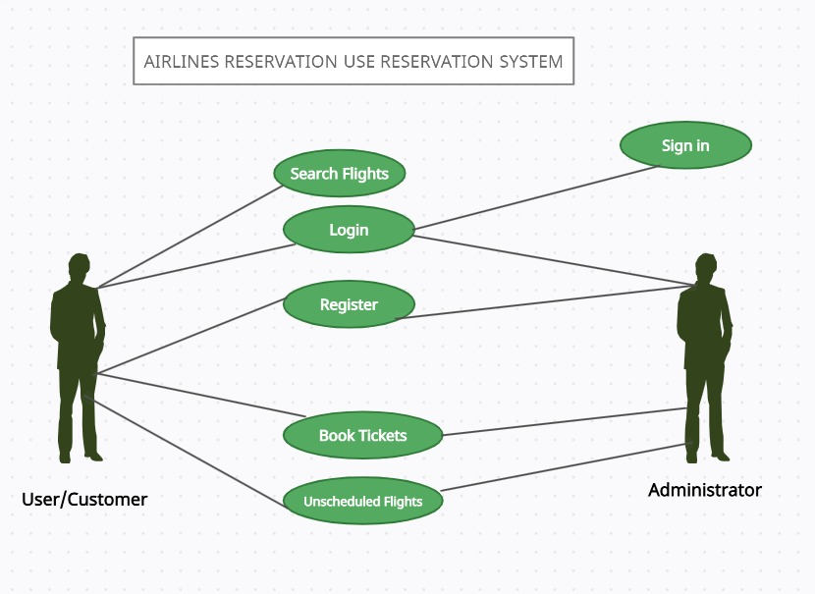

Sequence Diagram

